**Program:**

clear all;%clear workspace window

close all;%close all window except command window

clc;%clear command window

Am = input("Enter amplitude of the message signal: ");

Fm = input("Enter frequency of the message signal: ");

Ac = input("Enter amplitude of the carrier signal: ");

Fc = input("Enter frequency of the carrier signal: ");

Fs = input("Enter sampling frequency: ");

t = 0:0.001:1;%defining the time range

MI = Am/Ac; %defining modulating index

Mt =Am.*sin(2*pi*Fm*t);%defining the message signal

Ct =Ac.*sin(2*pi*Fc*t);%defining the carrier signal wave

St =(1+MI*Mt).*Ct;%Amplitude Modulated wave, according to the standard definition

O = St;

%defining a loop for rectification of the modulated signal

for i=1:length(t)

if O(i)<=0

O(i)=0;

end

end

[x,n] = butter(2,2*pi*Fm/Fs);%defining butterworth lpf of 2nd order

O1 = filter(x,n,O);

O2 = filter(x,n,O1);

O3 = filter(x,n,O2);

subplot(5,1,1)%plotting the message signal wave

plot(t,Mt);

title("Message Signal");

xlabel("Time(sec)---->");

ylabel("Amplitude--->");

subplot(5,1,2);%plotting the carrier signal wave

plot(t,Ct);

title("Carrier Signal");

xlabel("Time(sec)---->");

ylabel("Amplitude--->");

subplot(5,1,3);%plotting the amplitude modulated wave

plot(t,St);

title("Modulated AM Signal");

xlabel("Time(sec)---->");

ylabel("Amplitude--->");

subplot(5,1,4);%plotting the Rectified modulated wave

plot(t,O);

title("Rectified modulated Signal");

xlabel("Time(sec)---->");

ylabel("Amplitude--->");

subplot(5,1,5);%plotting the demodulated wave

plot(t,O3);

title("Demodulated Signal");

xlabel("Time(sec)---->");

ylabel("Amplitude--->");

**Command Window:**

Enter amplitude of the message signal: 1

Enter frequency of the message signal: 10

Enter amplitude of the carrier signal: 2

Enter frequency of the carrier signal: 100

Enter sampling frequency: 1000

**Output:**

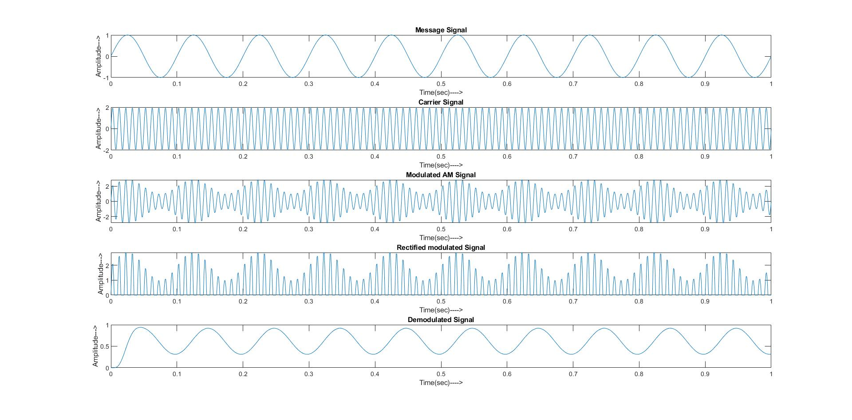

**Program:**

clear all;%clear workspace window

close all;%close all window except command window

clc;%clear command window

Fm = input("Enter frequency of the message signal: ");

Fc = input("Enter frequency of the carrier signal: ");

Fs = input("Enter sampling frequency: ");

T = input("Enter duration over which signal to be plotted: ");

C = input("Enter value of the capacitor of the filter: ");

t = 0:T/Fs:T;%defining the time range

Mt =cos(2*pi*Fm*t);%defining the message signal

Ct =cos(2*pi*Fc*t);%defining the carrier signal wave

St = Mt.*Ct;%DSB-SC Modulated wave, according to the standard definition

O = St.*Ct;

R = 1/(2*pi*Fm*C);%defining reactance of the capacitor

H = (1/(R*C))*exp(-t/(R*C));

h = conv(H,conv(O,H));

t1 =t;

for i=length(t)+1:length(h)

t1(i)=0;

end

subplot(4,1,1)%plotting the message signal wave

plot(t,Mt);

title("Message Signal");

xlabel("Time(sec)---->");

ylabel("Amplitude--->");

subplot(4,1,2);%plotting the carrier signal wave

plot(t,Ct);

title("Carrier Signal");

xlabel("Time(sec)---->");

ylabel("Amplitude--->");

subplot(4,1,3);%plotting the modulated wave

plot(t,St);

title("DSB-SC Modulated Signal");

xlabel("Time(sec)---->");

ylabel("Amplitude--->");

subplot(4,1,4);%plotting the demodulated wave

plot(t1,h);

title("Demodulated Signal");

xlabel("Time(sec)---->");

ylabel("Amplitude--->");

**Command Window:**

Enter frequency of the message signal: 10

Enter frequency of the carrier signal: 100

Enter sampling frequency: 1000

Enter duration over which signal to be plotted: .6

Enter value of the capacitor of the filter: 1e-8

**Output:**

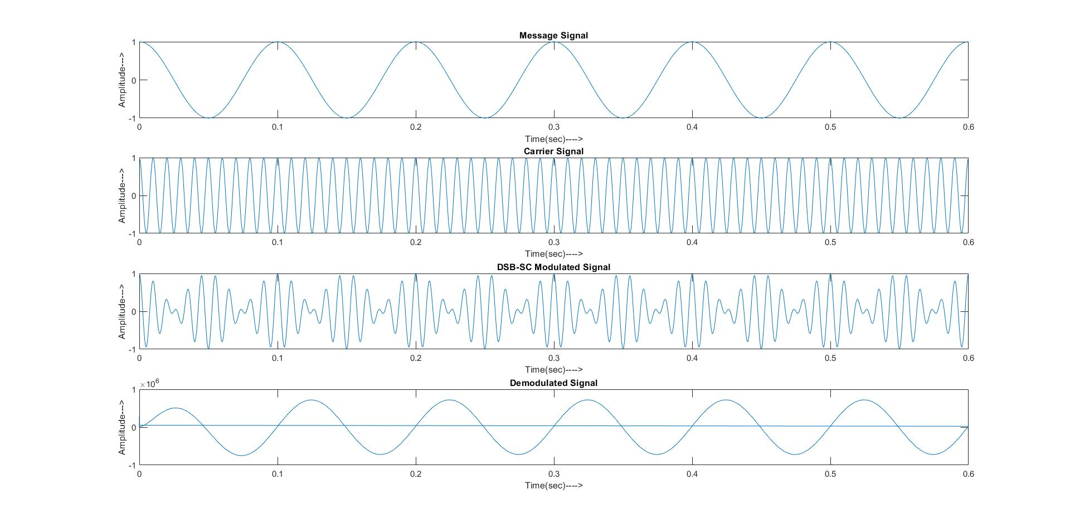

**Program:**

clear all;%clear workspace window